**Research Fellow: Nicholas Shek Lam Poon (2020) Major: Physics**

**Faculty Mentor: Linda Tseng Department(s): Environmental Studies; Physics**

**Title of Project: Quantitative microbial risk assessment along coastal Los Angeles**

**Project Summary:**

Fecal indicator bacteria (FIB) are used to measure the water quality at beaches. The three main indicators that are widely used are: enterococcus, total coliform, and fecal coliform. These indicators are used to track the presence of harmful pathogens that (in our case) would cause gastrointestinal illness (GI). FIB’s are not inherently harmful themselves, but they are used as strong indicators for total GI symptoms.

The goal of the research was to determine whether there was a correlation between human bacteroides levels (specific to human waste), measured by Professor Tseng’s collaborators in Los Angeles between 2009 and 2010, and the risk of GI (measured by the concentration of FIB). There are multiple sampling stations in Los Angeles that collect FIB concentrations at least once a week. Stations located within Manhattan County Beach, Hermosa Beach, and Redondo County Beach were all used in this research since all human bacteroides data collected have storm drains leading to these beaches.

To calculate the risk of GI, we chose a model distribution that best fits each of the publicly available dry weather FIB data from the years 2009 and 2010. This was done by fitting each distribution available on MATLAB to data of each indicator at each station. Then the distributions were narrowed down after comparing the data histograms to the distribution shape, and then finally by comparing their geometric mean. After plotting all the results into tables, it was determined the best fit for all FIB indicators is a lognormal distribution (plotted below for all indicators at station SMB 6-02).

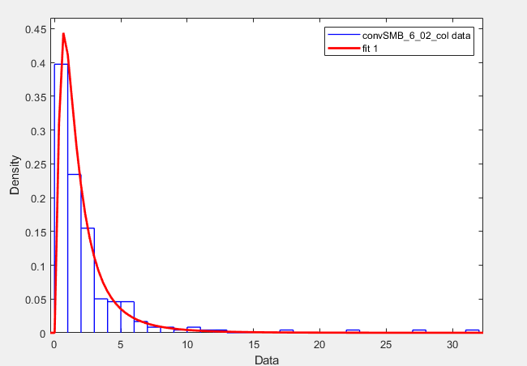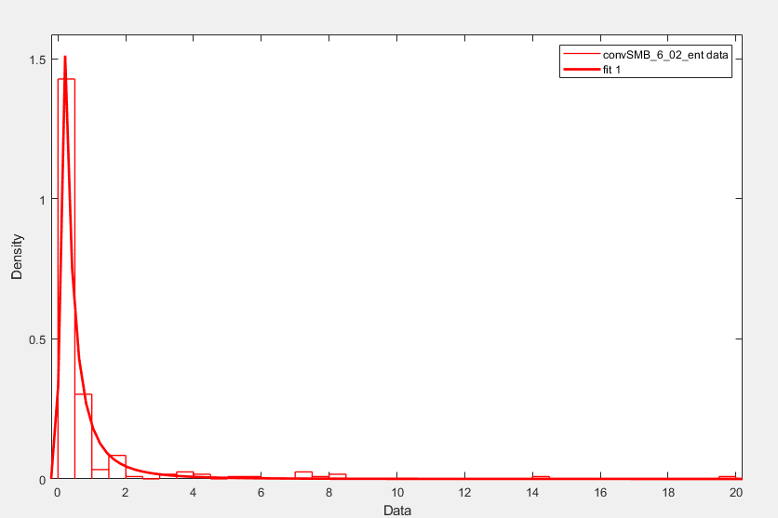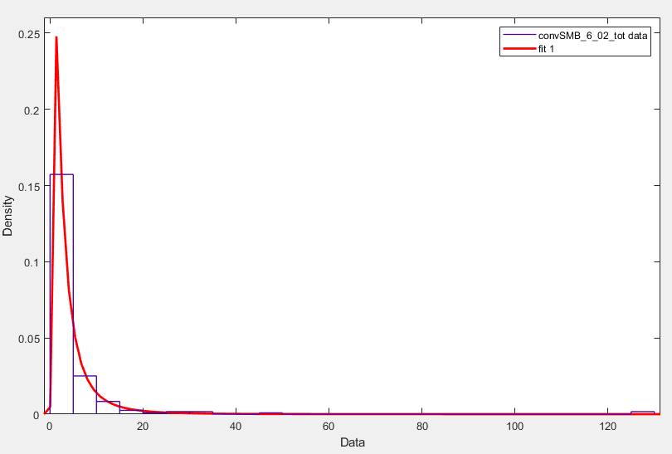

*Fecal Coliform*  *Enterococcus*  *Total Coliform*

With the FIB concentration model, we calculated the ingestion dose model using the following equation:

$D_{Oral}=I_{Oral} * C$

This was done by randomly sampling 10,000 points from the lognormal distribution curve of each FIB and multiplying each point to a point from 10,000 randomly sampled points from the ingestion volume curve. The ingestion volume was sampled from a lognormal distribution with parameters: mean = 3.54 ml d-1 (Note: d = day) and standard deviation = 1.80 ml d-1.

Lastly, we calculated the risk of GI (the dose-response models) using the following equations:

${p(ill)}_{ENT, day}=[1-exp(-D_{ENT, Oral} / k)] *Ψ$

${p(ill)}_{FC, day}=1 -[1+(D_{FC, Oral} / N_{50}) *(2^{ 1/α} - 1)]^{-α}$

Just like the ingestion dose model, the enterococcus dose-response model required randomly sampling 10,000 points for two variables (k and Ψ). The dose-response model for fecal coliform and total coliform, on the other hand, only used constants and thus had a final dose-response model that did not deviate.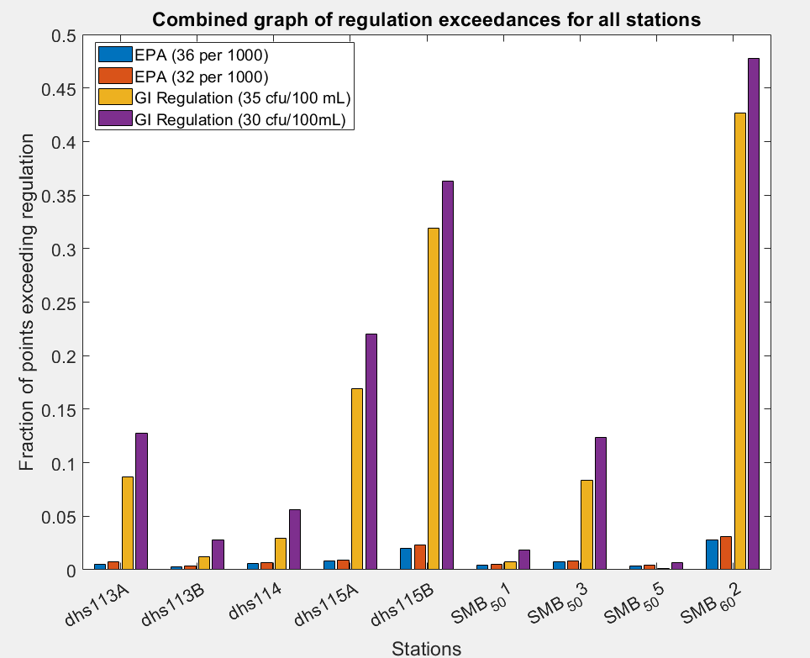

With the dose response models, we calculated the fraction of points (of the randomly sampled data) that exceeded EPA or GI regulation, based on probability of illness and FIB concentration respectively. Using the probability of illness appeared to be more protective.

With these results, we referenced human bacteroides data, which was collected in person in 2009-2019, and found that stations with high exceedance rates (figure to the right) correlated with high levels of human bacteroides at storm drains that led to these stations. This suggests recreational water activities near the storm drain would have higher GI risks.